Names ______________________________________________________________________________
EDUC 2551 – Elementary School Math: Geometry
Project 4

1. | 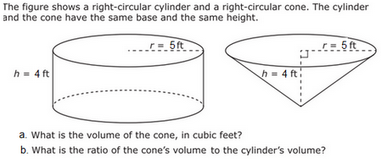  - Volume of cone= ( 4*3.142*5*5*4)/3=104.73 ft³  - Volume of cylinder=(4*3.142*5*5*)=314.2  Ratio = 314.2/104.73= 3
2. | Two dolphins are similar in shape. One is 4 ft long; the other is 1 ft long.  a. How many times heavier is the larger dolphin? 4 times  b. How many times more skin surface does the larger dolphin have? 4 times
3. | Find the total surface area and the volume of the triangular prism shown below.  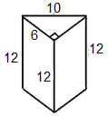  ^{Total surface area}  Area of Triangles= ½*6*8= 24*2=48  Area of rectangle1= 8*12= 96*2= 192  Area of rectangle2= 12*10=120*2=240  ^{Total area= 480}  Volume of triangular prism= Area of Triangle *12= 24*12= 288
4. | In the figures below, the radius and height of each right circular cylinder are given. If w, x, and y represent the respective volumes of the cylinders, order these volumes (w, x, and y) from least to greatest.  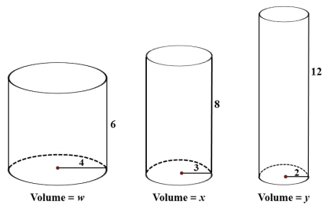  Volume w= 3.142*4*4*6=301.632  Volume x=3.142*3*3*8=226.224  Volume y=3.142*2*2*12=150.816  The order from least to greatest is Y, X, W
5. | 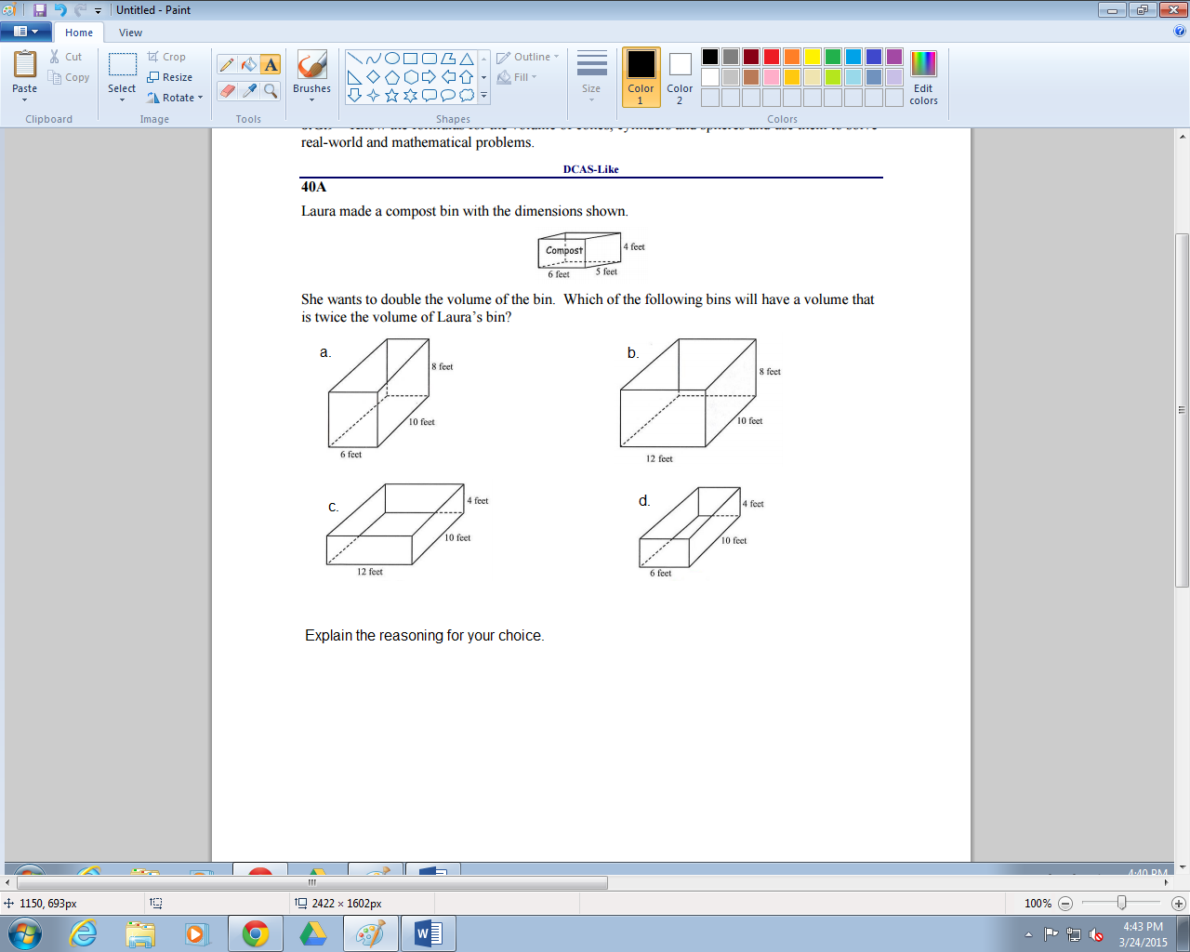  D is correct answer 6*10*4=240  240 is same as (6*5*4)*2=240
6. | 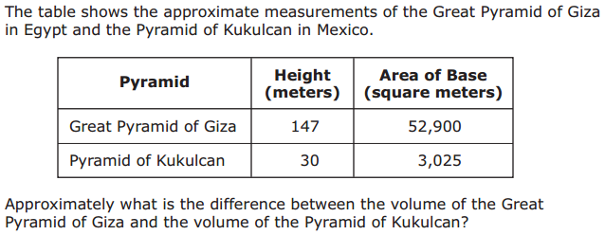  Giza volume=(147*52,900)=7776300  Kukulcan=(30*3025)= 90750  Difference= (7,776,300-90750)=7,685,550
7. | 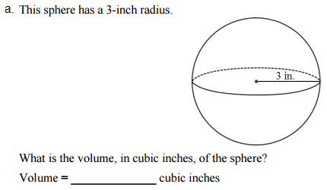,  V=4*3.142*3*3=113.112  What is the volume of a hemisphere with the same radius in cubic inches?
8. | 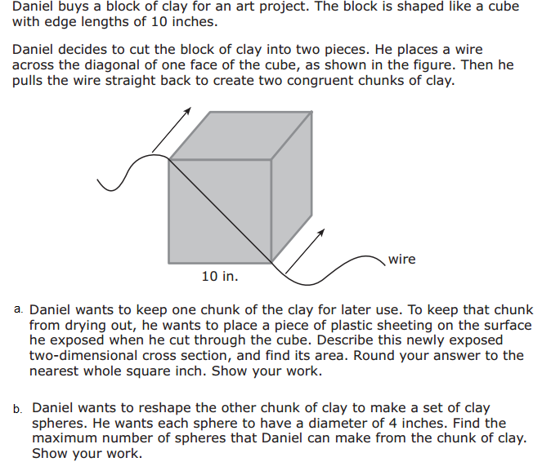  - The area exposed after cube is cut is (14.142*10)=141.42 inch. Rounding off we get 141 inch.  - V of sphere= (4*3.142*2*2*2)/3=20.568/3=6.856  V of chunk= (1/2*10*10*10)=500  Number of shepheres that can be made from chunk= 500/6.856=72

